**Outputs for Predictive Analysis of Customer Churn:**

**2. Data Import and Export Using Pandas: o Task: Write a Python script to import the dataset using the Pandas library. Understand the structure of the data by examining rows, columns, and basic characteristics like data types and missing values.**

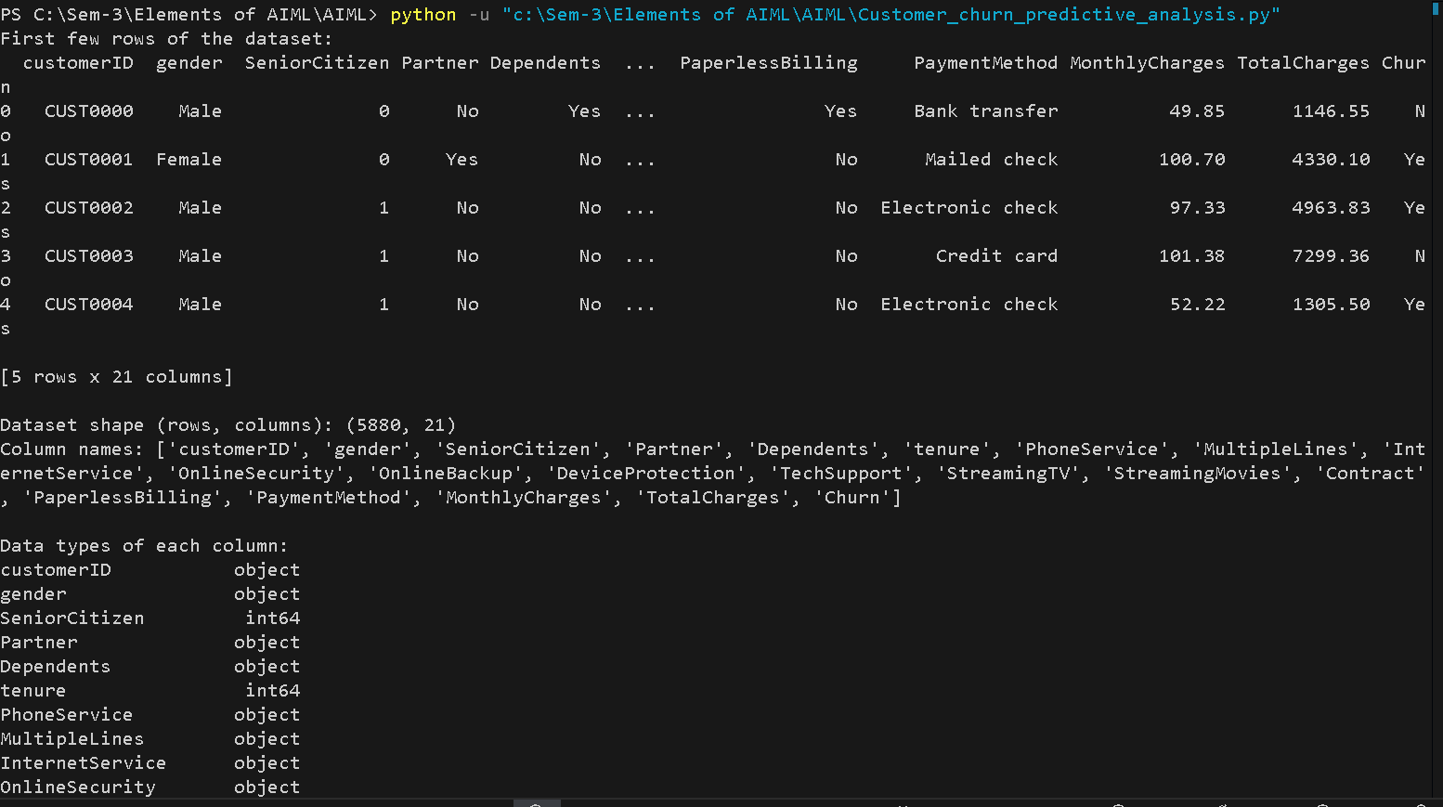

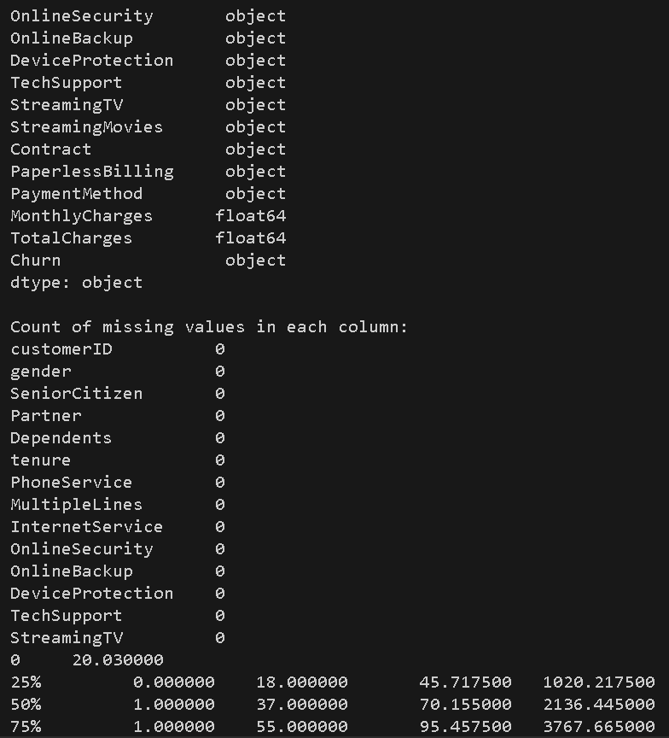

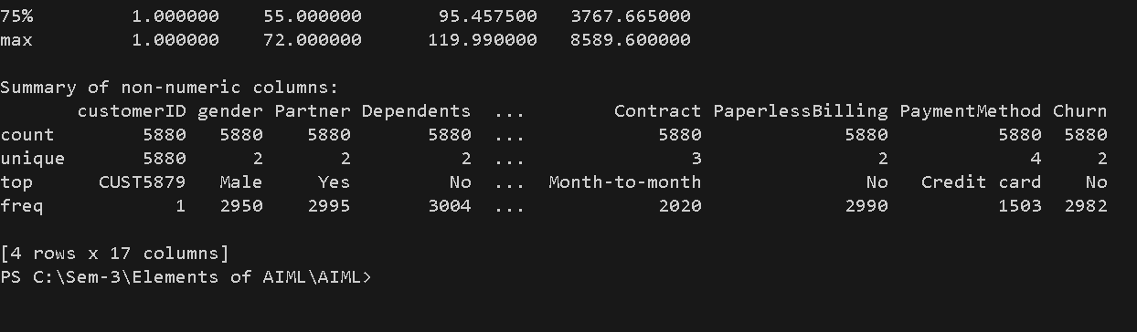

**3. Exploratory Data Analysis (EDA): o Task: Conduct EDA to uncover patterns, spot anomalies, and form hypotheses about factors influencing customer churn. Utilize statistical summaries and visualizations to understand the data’s underlying distribution and relationships.**

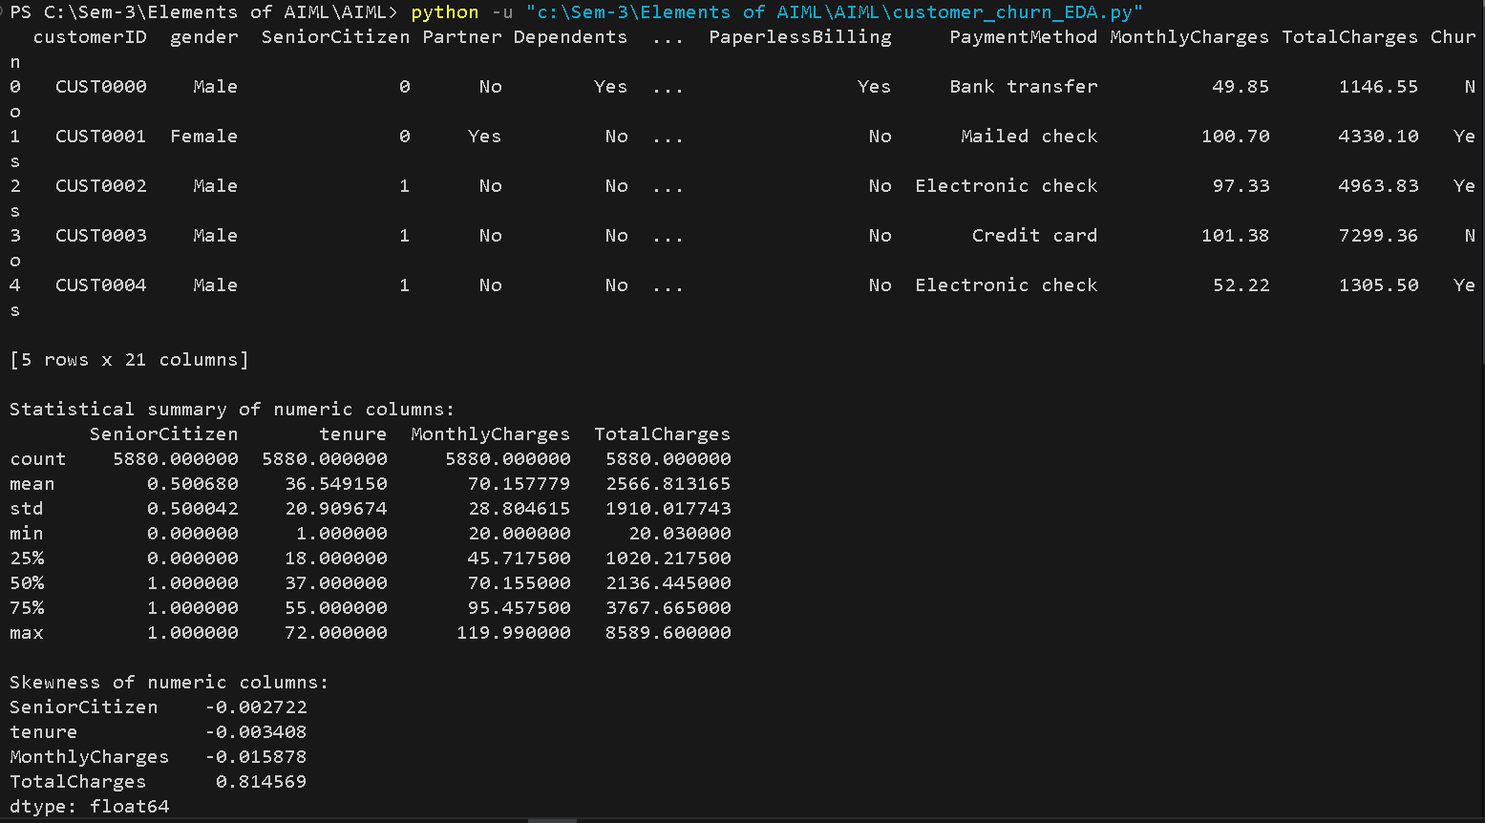

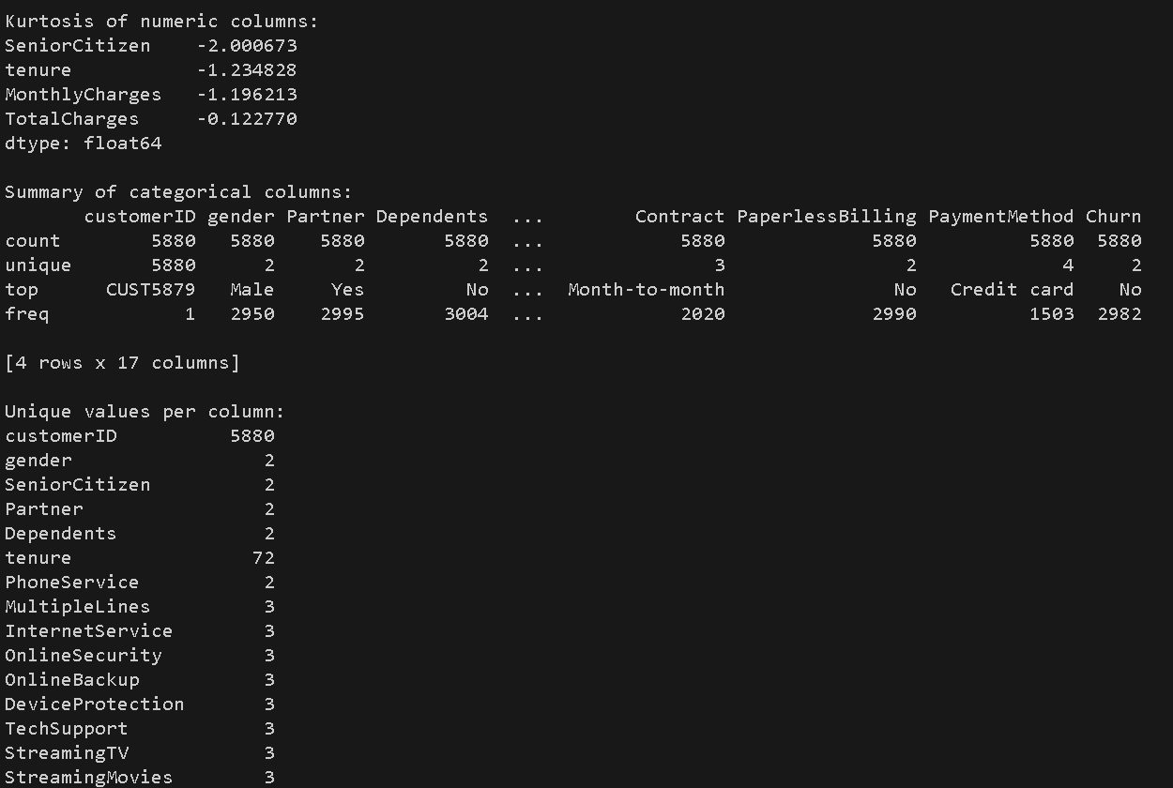

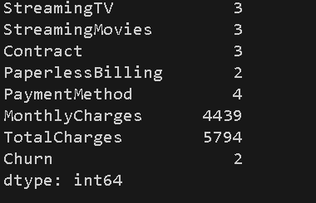

**4.** **Handling Missing Values and Outliers:**

**o Task: Implement data cleaning techniques to handle missing values either by filling them with appropriate values or removing the rows/columns. Detect and manage outliers in the dataset to prevent skewed results.**

